Stainless Steel Ice Cream Scoop kits Assembly Instructions
Required Accessories
• Drill bit: 8mm (BPD-8MM-PRC)
• Glue (Epoxy)
• Sanding and finishing supplies
• Blank size: Approximately 1-1/2" x 1-1/2" x 5" long
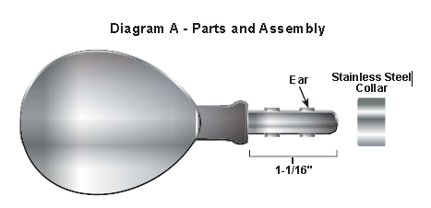
BLANK PREPARATION
The blank size will vary based on the profile of your design.
Generally, the size of your wood or acrylic blank should approximately 1-1/2" x 1-1/2” x 5" long. Mark the center of the blank on the end. Using a medium drill speed, drill a 8mm diameter hole x 1-3/16" deep. Raise the bit from the wood every 1/4" to 1/2" to allow the chips to clear from the flutes of the drill bit. Don’t force the drill bit; use an even pressure and let the bit do the work.
Note: If turning very hard woods or plastics, you may file off the ears on the shank, before assembly.

TURNING THE ICE CREAM SCOOP
Set up the blank between centers as shown in Diagram B.
Turn the blank to your own profile design. Sand with abrasives and finish with your choice of polish.
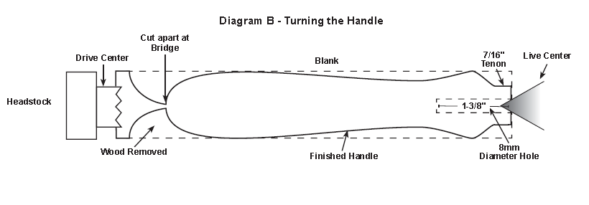
ASSEMBLY
Using epoxy when assembling the ice cream scoop. Spread epoxy over the scoop shaft. (Be sure not to get any epoxy on the scoop or exposed scoop post.) Insert the scoop shaft into the trim ring and then into the turned material to secure. When dry, the ice cream scoop is ready to use.

